
BUBlE CHRISTMAS 2026 PROMO PACKAGE

SHOW DESCRIPTION:

Bublé Christmas is much more than a tribute show.
It’s a theatrical concert experience filled with music, laughter, nostalgia and those unexpected moments that can bring an audience to tears.
Veteran stage performer Jay Davis brings his own style, humour and heart to the music of Michael Bublé, effortlessly moving between soaring, dynamic vocals and intimate storytelling. Rather than simply recreating the originals, Davis and his band put their own stamp on Bublé favourites, timeless standards and beloved Christmas songs, creating a show that feels spontaneous, personal and alive.
And this is no ordinary backing band. The musicians onstage are accomplished artists who have been staples of the Toronto jazz scene and beyond for more than 25 years. Their chemistry, musicianship and personalities become part of the show itself.
With theatrical elements woven throughout the evening, Bublé Christmas moves naturally from sophisticated and swinging to hilarious, heartfelt and deeply moving. One moment the room is laughing; the next, you can hear a pin drop.
It’s not about impersonating Michael Bublé. It’s about celebrating the music while creating something distinctly our own — a Christmas show with exceptional musicianship, genuine emotion, humour and heart.

ARTIST BIO – MICHAEL J. DAVIS
Jay Davis has spent more than three decades learning how to make an audience feel something.
An accomplished Canadian singer and actor with more than 100 professional stage and screen credits, Jay combines soaring, dynamic vocals with the instincts of a seasoned actor, the timing of an entertainer and the ability to turn a song into a story.
His career has taken him from Canada to Germany and London’s West End, where his credits include Jesus Christ Superstar for Andrew Lloyd Webber’s Really Useful Group and Miss Saigon for Cameron Mackintosh. In 2019, Jay joined the first international production of the Tony Award-winning musical Dear Evan Hansen. Over the course of his career, he has had the opportunity to work with Tony Award-winning directors Michael Greif and Gabriel Barre, and perform for acclaimed composers and creators including Adam Guettel, Stephen Schwartz and Andrew Lloyd Webber.
As a concert vocalist, Jay has performed with the Niagara Symphony Orchestra and Hamilton Philharmonic Orchestra and has been a featured vocalist for Disney Cruise Line, Holland America Line and Princess Cruises.
His work also extends to film and television, with appearances in productions including Designated Survivor, The Handmaid’s Tale and Titans, as well as numerous national commercials.
But résumés only tell part of the story.
At the heart of Jay's work is a love of live performance and the connection that can only happen in a room full of people. He moves effortlessly between powerhouse vocals and intimate storytelling, theatricality and spontaneity, genuine emotion and an unexpected laugh. Whether performing musical theatre, jazz, pop or country, Jay isn't interested in simply singing the notes. He looks for the story underneath them.
That philosophy has become the foundation of the concert productions he creates today. Rather than impersonating the artists who inspire them, Jay and his musicians bring their own personalities, arrangements and theatrical sensibilities to the music, creating shows in which exceptional musicianship is only part of the experience.
Because after more than 30 years onstage, Jay still believes the most memorable performances aren't necessarily the ones where you remember every song.
They're the ones where you remember how you felt.

REVIEWS:

"Jay was amazing!! What a wonderful performance! He has such a wonderful voice and he had MB's moves off to a T. If he was running a second show, I would be there for sure!

Gill M. Burlington Ontario

“This band is excellent, the singer is smooth, and the evening is a hit. This show has an uplifting and powerful universal theme of hope, love and togetherness delivered with sincerity and humour.” Check it out if you like Bublé, jazz music, or just having a good time.”
Sookie Mei, Entertain This Thought

"Excellent show!! We were both thoroughly entertained!! Thank you!!"

Teresa S. Owen Sound Ontario

"The afternoon show was energizing with amazing music. A "must see" performance. Jay and band ......well done!!"

Lynda A. Calgary Alberta

"My daughter, two friends & myself attended the Michael Buble’ tribute today & were absolutely shocked at how well Jay Davis & his combo performed. My daughter & I have had the privilege of seeing the real Buble’ perform in person & can only say that if u cannot see Michael Buble’ perform then go see the next best thing. We will definitely go to watch Jay Davis & his combo perform any time they are in our area. A show not to be missed."

Lin K. Kitchener Ontario

STAGE PLOT
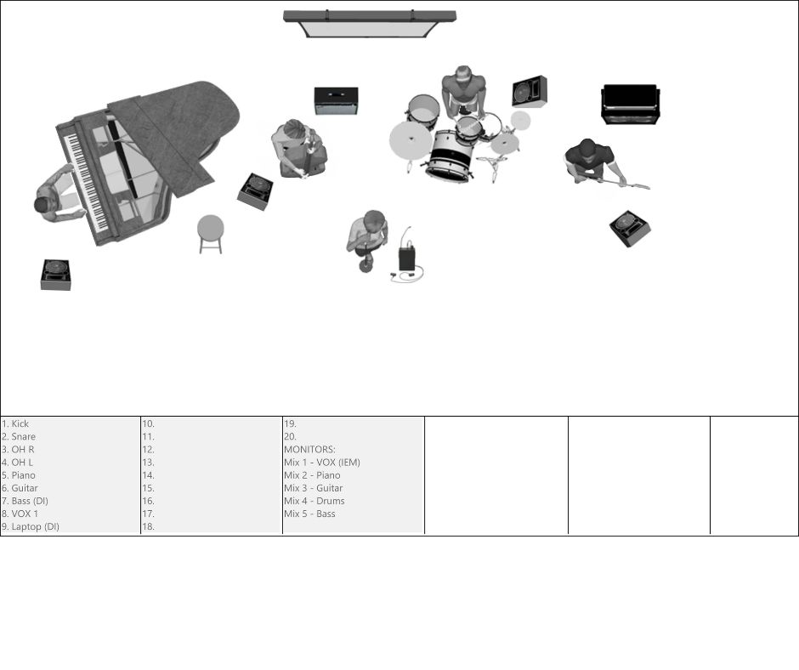

SHOW OVERVIEW
Bublé Christmas is a fully self-contained, concert-style holiday production inspired by the music of Michael Bublé and classic Christmas standards. Designed specifically for mid to largescale theatres, the show blends worldclass musicianship, cinematic projections, warmth, humour, and emotional storytelling into a polished 90minute audience experience.
Led by Canadian musical theatre star Jay Davis and backed by the acclaimed Feeling Bublé Band, the show feels less like a tribute and more like a seasonal event—festive, contemporary, and deeply engaging.
• 90 minutes + intermission
• Familyfriendly
• Turnkey touring package
• Suitable for proscenium and thrust stages

WHY IT WORKS FOR THEATRES
• Strong boxoffice appeal during the holiday season
• Appeals to broad demographics (30–75)
• Minimal technical risk with high production value
• Scales cleanly from 300–1,200 seat venues
• Simple advancing and predictable running time
The show has successfully played major Ontario venues including the Kingston Grand Theatre, River Run Centre (Guelph), Sanderson Centre (Brantford), and others.

THE SHOW EXPERIENCE
Tone:
Warm, festive, elegant, and joyful—with moments of intimacy and humour.
Audience Response:
Singalongs, laughter, standing ovations, and strong word of mouth.
Highlights Include:
• Swing and bigband favourites
• Christmas classics
• Emotional ballads
• Playful theatrical moments
• Audience engagement without participation pressure

SAMPLE SET LIST
ACT 1 (Selections):
• It’s Beginning to Look a Lot Like Christmas
• Haven’t Met You Yet
• Santa Claus Is Coming to Town
• Rainbow Connection
• GrownUp Christmas List
• White Christmas
• Let It Snow
• Everything
• All I Want for Christmas Is You
ACT 2 (Selections):
• You’re the First, the Last, My Everything
• Holly Jolly Christmas
• Sway
• Feeling Good
• Ave Maria
• Live Like You Were Dying
• Have Yourself a Merry Little Christmas
Encore:
• Silent Night / Singing for You
(Full running order and cue structure available on request.)

VIDEO LINKS
https://youtu.be/e-5OvJgX4-Y
https://youtu.be/AVnQ0KSbdKo

BOOKING INFORMATION
Tour Window:
Late November – December
jay@jaydavisproductions.com

Ideal Venues:
• 300–1,200 seats
• Presenting houses, PACs, municipal theatres

TECH RIDER

BAND LAYOUT
Band Configuration (Typical):
- Lead Vocal (Jay Davis) – Downstage Centre
- Piano / Keys – Stage Left
- Drums – Upstage Centre
- Bass – Stage Right
- Guitar – Stage Right or Upstage Right
(Refer to supplied stage plot image for spacing and monitor placement.)
ONSTAGE REQUIREMENTS
- One handheld wireless OR wired microphone on stand, Downstage Centre
- One (or two) black stool, preset upstage near the band
- Small table (discreet, stage appropriate)
- Monitors for all band members
- Artist sings using in-ear monitors (IEMs), provided by the artist

AUDIO & MIX GUIDELINES
- Only one track at top of show in the first video cue
- Please feature instrumental solos clearly in the mix
- Minimal compression on lead vocal is preferred where possible
- Lead vocals should be clear and out front

VIDEO / PROJECTION DETAILS
- QLab playback operated from artist’s MacBook Pro
- One motion graphic per song
- Press the space bar at the start and end of every song
- HDMI connection required at FOH or stage-side
- Projection surface: upstage screen, cyc, or LED wall

LIGHTING NOTES
- House lighting system sufficient
- Moving lights welcome
- Programmer/operator encouraged to use discretion and musicality
- No strobe or aggressive effects required

SHOWTIME FLOW & PRE-SHOW
Pre-Show:
- Pre-show graphic and music runs from QLab
- Stage is open and visible at top of show
- Marquee graphic displayed on screen
Preset at Top of Show:
- Mic stand Downstage Centre
- Stool upstage near band
- Small table in place
Show Start:
- Tech script to be provided

18. POWER & TECH NOTES
- Standard theatrical power sufficient
- Edison outlets required onstage
- No special power requirements
Jay Davis
📞 647-206-5545
📧 jay@jaydavisproductions.com
📧 jaytothedavis@gmail.com
📍 Toronto, Ontario
🌐 www.jaydavisproductions.com

